**Excel Spreadsheets Financial Functions**

the 4 most useful ones.

|  |  |
| --- | --- |
| **Functions** | **What it Does** |
| **FV** | Returns the future value of an investment |
| **NPER** | Returns the number of periods for an investment |
| **PMT** | Returns the periodic payment for an annuity |
| **RATE** | Returns the interest rate per period of an annuity |

**The RATE Function**

The question to which **RATE**  brings an answer to is:  
- What is the real interest rate if they ask me for a certain amount each period to pay a loan?

|  |  |  |
| --- | --- | --- |
|  | **A** | **Descriptions** |
| **1** | 48 | Number of periods (years, months, weeks..etc) |
| **2** | $550 | Periodic payment |
| **3** | $24,000 | Total amount of loan |
| **4** | 0 | The balance left to pay at the end of the period. If you omit this argument Excel uses "0". |
| **5** | 0 | Payment made at the beginning of the period (1) or at the end of the period (0). If you omit this argument Excel uses "0" saying that the payment is made at the end of each period which is usually the reality when you borrow money. |
| **6** | **5.00%** | The result with the formula using the **RATE** function. **Note: the format of this cell must be "Percentage" with any number of decimals. In this example the number of decimals is 2** |

Here is the formula in cell A6:  
**=RATE(A1,-A2,A3,A4,A5)*12**

**Notes on the formula:** The payment argument is negative (-A2); If you use months as periods and you want an annual rate you multiply by 12, if you use a years as periods and you want an annual rate you don't multiply......; If you don't use the "Percentage" format in cell A6 the result of this example will be 0.05; The formula could also be **=RATE(A1,-A2,A3)*12** the arguments in A4 and A5 being optional

**The PMT Function**

The question to which **PMT** brings an answer to is:  
- If I borrow a certain amount of money and I want it repaid at the end of a certain period of time what will be the periodic payment?

|  |  |  |
| --- | --- | --- |
|  | **A** | **Descriptions** |
| **1** | 5.00% | The annual interest rate. **Note: the format of this cell must be "Percentage" with any number of decimals. In this example the number of decimals is 2** |
| **2** | 48 | Number of periodic payments (years, months, weeks) |
| **3** | $24,000 | Total amount of loan |
| **4** | 0 | The balance left to pay at the end of the period. If you omit this argument Excel uses "0". |
| **5** | 0 | Payment made at the beginning of the period (1) or at the end of the period (0). If you omit this argument Excel uses "0" saying that the payment is made at the end of each period which is usually the reality when you borrow money. |
| **6** | -$550.41 | The result with the formula using the **PMT** function. |

Here is the formula in cell A6:  
**=PMT(A1/12,A2,A3,A4,A5)**

**Notes on the formula:** If you don't use the "Percentage" format in cell A1 enter 0.05; If you use months as periods the rate must be divided by 12 (A1/12), if you use weeks then you divide by 52 (A1/52), if there are 4 payments per year you will divide the rate by 4 (A1/4)and if the payment is annual you don't divide the rate argument (A1) ; The formula could also be **=PMT(A1/12,A2,A3)** the arguments in A4 and A5 being optional; If you want the payment to show as a positive value add a minus sign before the equal sign (**=-PMT(A1/12,A2,A3,A4,A5)**)

**The FV Function (Future value)**

The question to which **FV**  brings an answer to is:  
- If I put a certain amount of money in the bank each month how much money will I have saved at the end of a certain period of time?

|  |  |  |
| --- | --- | --- |
|  | **A** | **Descriptions** |
| **1** | 5.00% | The annual interest rate. **Note: the format of this cell must be "Percentage" with any number of decimals. In this example the number of decimals is 2** |
| **2** | 48 | Number of periodic deposits (years, months, weeks) |
| **3** | $550 | Amount of periodic deposits |
| **4** | $0 | Beginning balance. If you omit this argument Excel uses "0". |
| **5** | 1 | Deposits made at the beginning of the period (1) or at the end (0). If you omit this argument Excel uses "0". In the case of the FV function make sure that you enter "1". |
| **6** | -$29,279.68 | The result with the formula using the **FV** function. |

Here is the formula in cell A6:  
**=FV(A1/12,A2,A3,A4,A5)**

**Notes on the formula:** If you don't use the "Percentage" format in cell A1 enter 0.05; If you use months as periods the rate must be divided by 12 (A1/12), if you use weeks then you divide by 52 (A1/52), if there are 4 payments per year you will divide the rate by 4 (A1/4)and if the payment is annual you don't divide the rate argument (A1) ; The formula could also be **=FV(A1/12,A2,A3)** the arguments in A4 and A5 being optional; If you want the RESULT to show as a positive value add a minus sign before the equal sign (**=-FV(A1/12,A2,A3,A4,A5)**)

**The NPER Function**

The question to which **NPER**  brings an answer to is:  
- How many months would it take me to repay a certain loan at a certain interest rate if I pay a certain amount each month?

|  |  |  |
| --- | --- | --- |
|  | **A** | **Descriptions** |
| **1** | 5.0% | The annual interest rate. **Note: the format of this cell must be "Percentage" with any number of decimals. In this example the number of decimals is 2** |
| **2** | $550 | Periodic payment |
| **3** | $24,000 | Total amount of loan |
| **4** | 0 | The balance left to pay at the end of the period. If you omit this argument Excel uses "0". |
| **5** | 0 | Payment made at the beginning of the period (1) or at the end (0). If you omit this argument Excel uses "0". |
| **6** | **48.26** | The result with the formula using the **NPER** function. |

Here is the formula in cell A6:  
**=NPER(D1/12,-D2,D3,D4,D5)**

**Notes on the formula:** If you don't use the "Percentage" format in cell A1 enter 0.05; The second argument MUST BE NEGATIVE; If you use months as periods the rate must be divided by 12 (A1/12), if you use weeks then you divide by 52 (A1/52), if there are 4 payments per year you will divide the rate by 4 (A1/4)and if the payment is annual you don't divide the rate argument (A1) ; The formula could also be **=NPER(A1/12,A2,A3)** the arguments in A4 and A5 being optional;

Financial Functions

Pmt | Rate | Nper | Pv | Fv

To illustrate Excel's most popular financial functions, we consider a loan with monthly payments, an annual interest rate of 6%, a 20-year duration, a present value of $150,000 (amount borrowed) and a future value of 0 (that's what you hope to achieve when you pay off a loan).

We make monthly payments, so we use 6%/12 = 0.5% for Rate and 20*12 = 240 for Nper (total number of periods). If we make annual payments on the same loan, we use 6% for Rate and 20 for Nper.

Pmt

Select cell A2 and insert the PMT function.

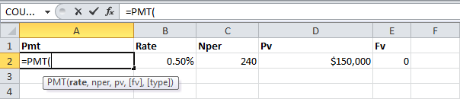

Note: The last two arguments are optional. For loans the Fv can be omitted (the future value of a loan equals 0, however, it's included here for clarification). If Type is omitted, it is assumed that payments are due at the end of the period.

Result. The monthly payment equals $1,074.65.

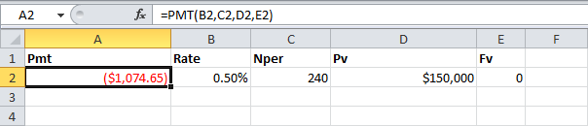

Tip: when working with financial functions in Excel, always ask yourself the question, am I making a payment (negative) or am I receiving money (positive)? We pay off a loan of $150,000 (positive, we received that amount) and we make monthly payments of $1,074.65 (negative, we pay).

Rate

If Rate is the only unknown variable, we can use the RATE function to calculate the interest rate.

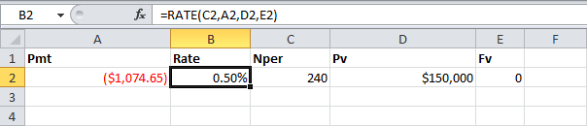

Nper

Or the NPER function. If we make monthly payments of $1,074.65 on a 20-year loan, with an annual interest rate of 6%, it takes 240 months to pay off this loan.

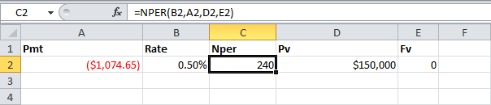

We already knew this, but we can change the monthly payment now to see how this affects the total number of periods.

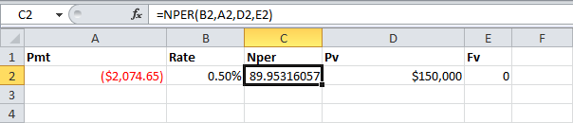

Conclusion: if we make monthly payments of $2,074.65, it takes less than 90 months to pay off this loan.

Pv

Or the PV (Present Value) function. If we make monthly payments of $1,074.65 on a 20-year loan, with an annual interest rate of 6%, how much can we borrow? You already know the answer.

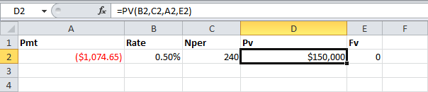

Fv

And we finish this chapter with the FV (Future Value) function. If we make monthly payments of $1,074.65 on a 20-year loan, with an annual interest rate of 6%, do we pay off this loan? Yes.

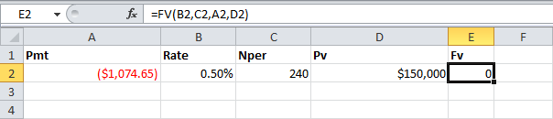

But, if we make monthly payments of only $1,000.00, we still have debt after 20 years.

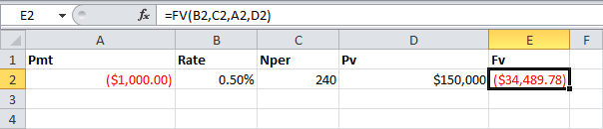

## **PMT Function**

The PMT function calculates the monthly payments for a loan based on constant payments and a constant interest rate.

As an example let’s day we have a loan with monthly payments, an annual interest rate of 8%, a 30-year duration, a present value of $200,000, and a future value of 0 (amount of debt remaining after making all repayments).

We make monthly payments so we put a rate of 0.66% (this is what you get when you divide 8% by 12 months). Subsequently, we set 360 for nper (30 years * 12 months) which is the total number of periods.

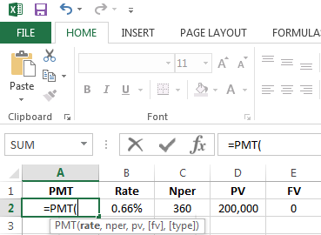Using the PMT function in Excel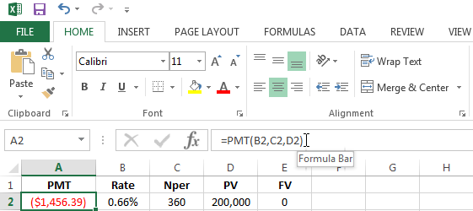Example of a completed PMT function in Excel

In this case you would have to pay $1,456.39 dollars per month to repay your loan in 30 years.

Note that for loans FV can be omitted (FV of a loan equals 0). If Type is left out Excel assumes that payments will be due at the end of each period.

## **RATE Function**

Using the same example, it might be the case that instead of not knowing the monthly payment, you have that information but you don’t know how much the rate is. In this case, you can use the RATE function to calculate the interest rate.

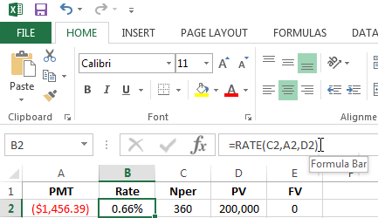Using the RATE function in Excel

## **NPER Function**

In a similar fashion, when you don’t know the number of periods but you do have all the other information, you should use the NPER function to calculate the number of periods.

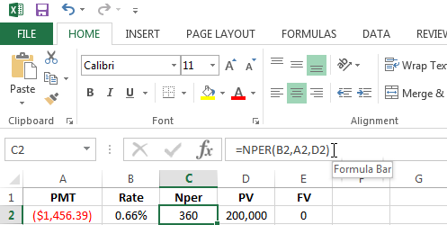Using the NPER function in Excel

Another thing you can do is play around with the number of months in your calculations to see how it impacts the monthly payments.

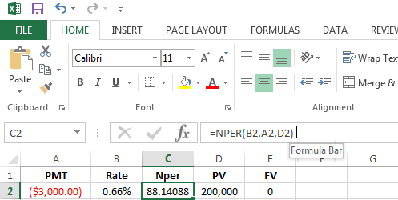Find the number of repayment periods necessary with different monthly payments

In this case if you increase the monthly repayments to $3,000 dollars per month, you will only need 88 periods to pay back your loan.

## **PV Function**

And you might have understood the pattern already, but if you know all the other data while you don’t know the loan amount, you can use the PV function to find out how much money is borrowed given you know the monthly payments, the interest rate, and number of periods.

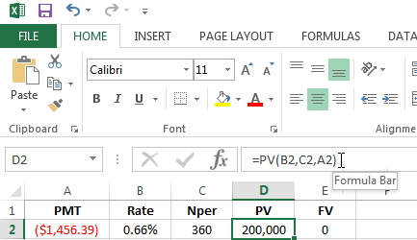Using the PV function in Excel

## **FV Function**

Use the FV function to determine if you will successfully pay off your debt or will have outstanding debt given you make certain monthly payments, on a loan with an interest rate.

In the first example it shows that by paying $1456.39 you will pay off your loan in 30 years, but if you only make monthly payments of $1400 as is shown in the second example, you’ll be left with a debt of $82689.88 at the end of the period.

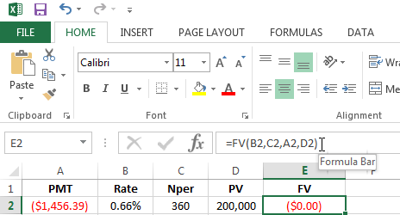Using the FV function in Excel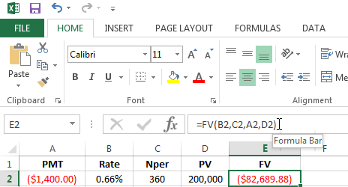Find the amount of debt remaining after finishing all repayment periods with different monthly payments